Name-Aditi Sudhir Igade

Div-A Roll no-221081

PRN. No-22220311

Assignment -2

**PROBLEM STATEMENT: -**

Develop an object oriented program in java to create a database of Covid_Patient information system containing the following information: Name, ID, Date of Birth, Blood group, Test_Report, Contact address, telephone number, Aadhar Number etc using 1.Constructor,2 Constructor Overloading

**Aim-**To write a program to create a database of covid patient.

**OBJECTIVE: -**

To write a program to Covid Patient database by applying object-oriented concepts of class, object, array of objects.

**THEORY:-**

## In [Java](https://www.javatpoint.com/java-tutorial), a constructor is a block of codes similar to the method. It is called when an instance of the [class](https://www.javatpoint.com/object-and-class-in-java) is created. At the time of calling constructor, memory for the object is allocated in the memory.It is a special type of method which is used to initialize the object.Every time an object is created using the new() keyword, at least one constructor is called.It calls a default constructor if there is no constructor available in the class.

**ALGORITHM:-**

1. Create Class Patient
2. Declare variables as name,id,dob,test-report,address,number.
3. Accept the information as name,id,dob from the patient.
4. Store the data in required variables.
5. Display the data.

**Code**-

import java.util.Scanner;

class Patient{

public String name;

public int id;

public int dob;

public String test_report;

public String contactAddress;

public String aadharNumber;

Patient(){

System.out.println("The default constructor is invoked");

}

Patient(String name,int id,int dob,String test_report,String contactAddress,String aadharNumber){

this.name=name;

this.id=id;

this.dob=dob;

this.test_report=test_report;

this.contactAddress=contactAddress;

this.aadharNumber=aadharNumber;

}

public String info(){

return "Name= "+this.name+"\nID= "+this.id+"\nDOB= "+this.dob+"\nTest report= "+this.test_report+"\nContact Address="+this.contactAddress+"\nAadhar Number= "+this.aadharNumber+"\n";

}

}

class Main {

public static void main(String[] args) {

Scanner sc=new Scanner(System.in);

//Patient p=new Patient[];

System.out.println("Enter the no. of patients");

int n=sc.nextInt();

Patient []p=new Patient[n];

for(int i=0;i<n;i++){

System.out.println("Enter the name of patient"+(i+1));

String s=sc.next();

System.out.println("Enter the ID of patient"+(i+1));

int id=sc.nextInt();

System.out.println("Enter the DOB of Patient"+(i+1));

int dob=sc.nextInt();

System.out.println("Enter the Test Report"+(i+1));

String a=sc.next();

System.out.println("Enter the contact address of patient"+(i+1));

String v=sc.next();

System.out.println("Enter the Aadhar Number"+(i+1));

String g=sc.next();

Patient p1=new Patient(s,id,dob,a,v,g);

p[i]=p1;

}

for(int i=0;i<n;i++){

System.out.println(p[i].info());

}

}

}

**Output-**

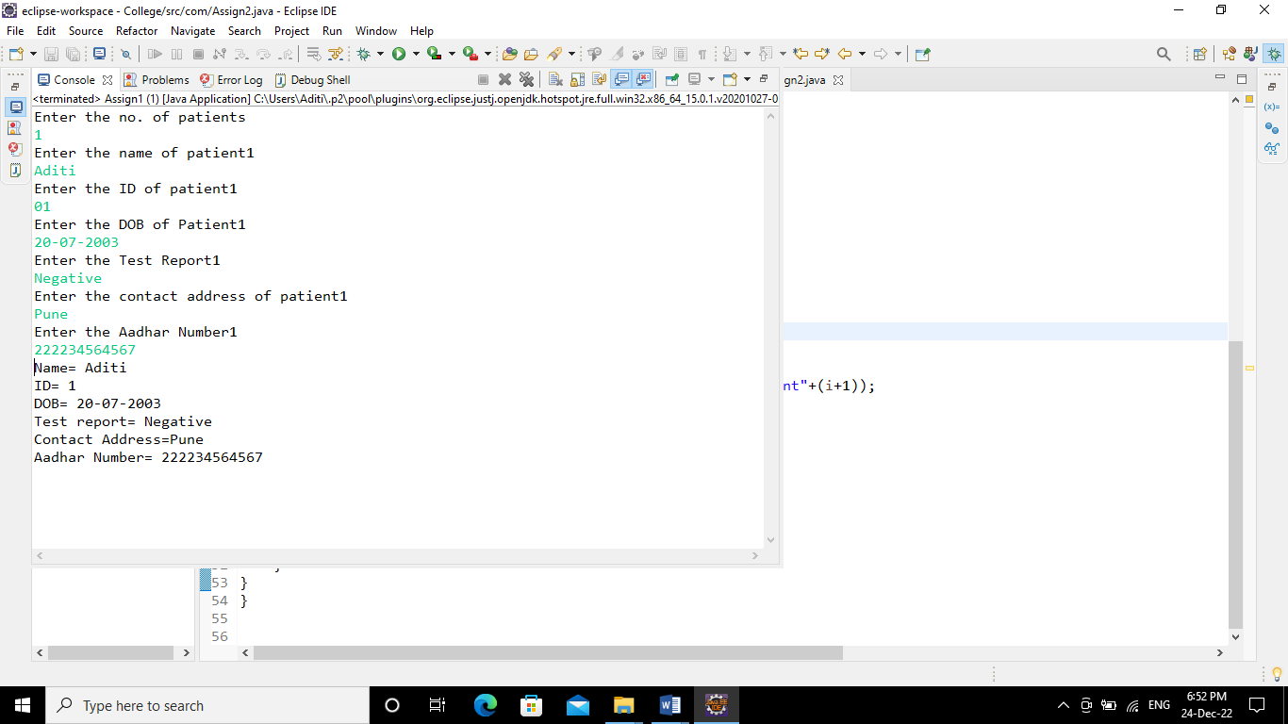

**Conclusion-** Able to apply the object oriented concepts to create patient database.